THREAD
- Introduction:
- Ways to define a thread
  - By extending Thread class
  - By implementing Runnable interface
- Getting & Setting name of Thread
- Thread Priority
- The methods to prevent thread execution
  - Yield()
  - Join()
  - Sleep()
- Synchronization
- Inter Thread Communication
- Deadlock
- Demon Thread
- Multithread enhancements
  - Thread local
  - Thread Group
  - Thread Pool Executors

- Introduction:
Multitasking:
Executing multiple tasks simultaneously.
Example:
Class room students
- Taking running notes
- Listening the class

Two types of Multitasking:
- Process based multitasking:
  - Executing several tasks simultaneously where each tasks is a separate independent process
  - Suitable for OS level.
- Thread based multitasking
  - Executing several tasks simultaneously where each tasks is a separate independent part of a program and each independent part is called a thread.
  - Suitable for programmatic level.

Example:
Process based multitasking:
- Typing a java program in editor
- Listen song from the same system
- Downloading a file from internet
Above multiple tasks are independent and running in separate process.

Advantage of multitasking:
- To increase performance
- To reduce CPU idle time or response time of system

- Ways to define a thread
Thread:
A thread is a separate flow of execution.
For every thread, a separate independent job is there.

Thread Defining:
We can define a thread by following two ways.
- By extending Thread class
- By implementing Runnable interface

- By extending Thread class:

Class MyThread extends Thread{
public void run(){ // run() contains the job of the thread
for(int i=0; i<10; i++){
System.out.println(“Child Thread:”+i);
}
}
}

MyThread is the thread and the body of the run() is the job of the thread.

To start a thread:
Class ThreadDemo{
public static void main(String args[]) {
MyThread t= new MyThread();
/* From above line, Main thread instantiate the Child Thread which is called as Thread instantiation. From here only one thread is there which is main thread */
t.start(); //start the child thread. From here, two threads are there main and child thread
for(int i=0; i<10; i++){
System.out.println(“Main Thread:”+i);
}

}
}

In above, main thread creates child thread object and main thread starts the child thread.

Thread Scheduler:
- It is responsible to schedule the thread execution.
- It is the part of JVM
- If multiples threads are waiting, in which order the threads will be executed is decided by thread scheduler.
- The thread scheduler decides the order based on its algorithm implemented.
- We cannot expect the exact algorithm followed by thread scheduler. It varies from jvm to jvm and hence we cannot expect the thread execution order and its exact output.
- Whenever situation comes to multithreading, there is no guarantee for exact output but we can provide several possible outputs.
- Various thread scheduling algorithms like Round robin, FIFO, Shortest Job first.
- Based on the algorithm implemented in jvm for thread scheduler, it decides the waiting thread order to execute.
Case Study:
- Diff b/w t.start() and t.run():
  - If I call t.start(), a separate flow of execution is created and start() internally calls the run().
  - If I call t.run() directly, it will not create a separate flow instead it will be executed in the main thread itself.

- Thread class start():
  - It is responsible to register the thread with thread scheduler, perform all other mandatory activities and finally invoke the job of thread which we have inside run().
  - Without executing the Thread class start(), there is no chance of starting a new thread in java.
  - Due to this, thread class start() is considered as heart of multithreading.

- Overloading run():
  - We can overload the run() but always thread class start() calls the no argument run() only.
Class MyThread extends Thread{
public void run(){
System.out.println(“child thread”);
}
public void run(int i){
System.out.println(“run:”+i);
}
}

Class ThreadDemo {
public static void main(String args[]){
MyThread t=new MyThread();
t.start(); // It always call the no argument run() internally
}
}

- Not overriding run():
  - If we are not overriding run(), then thread class start() check the run() in the child thread, if it is not available, it call the parent class (Thread) run() which doesn’t have implementation.
  - It is highly recommended to override the run().

Class MyThread extends Thread{
}

Class ThreadDemo {
public static void main(String args[]){
MyThread t=new MyThread();
t.start();
}
}

- Overriding start() and run():
  - If we override start(), then our start() will be executed just like a normal method call and starting a new thread will not be created.
Case1:
Class MyThread extends Thread{
public void start(){
System.out.println(“start”);
}
public void run(){
System.out.println(“child thread”);
}
}

Class ThreadDemo {
public static void main(String args[]){
MyThread t=new MyThread();
t.start();
System.out.println(“main thread”);
}
}

O/P: main thread
start

Case2:
Class MyThread extends Thread{
public void start(){
super.start(); // calls the Thread class start() which is responsible to start a new thread
System.out.println(“start”);
}
public void run(){
System.out.println(“child thread”);
}
}

Class ThreadDemo {
public static void main(String args[]){
MyThread t=new MyThread();
t.start();
System.out.println(“main thread”);
}
}

Life Cycle of Thread

New/ Born
Ready/ Runnable
t.start()
If thread scheduler allocates process
Running
Dead

Running of run() & run() completes go to dead

- By implementing Runnable interface

Class MyRunnable implements Runnable{
Public void run(){
System.out.println(“Child Thread”);
}
}

Class ThreadDemo {
public static void main(String args[]){
MyRunnable r=new MyRunnable();
Thread t=new Thread(r);
t.start();
}
}

Diff b/w extending Thread class and implementing Runnable Interface:
- In extending Thread class, there is no chance of extending other class. We lack inheritance.
- In implementing Runnable interface, we can extend other class so we get the inheritance benefit.
- Runnable interface approach is recommended because of above.

Thread Class Constructors:
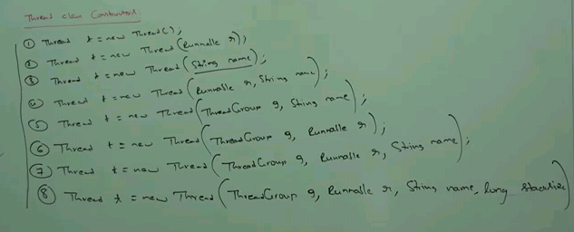

Another way to start thread:
Class MyThread extends Thread{
public void start(){
System.out.println(“start”);
}
}

Class ThreadDemo {
public static void main(String args[]){
MyThread t=new MyThread();
Thread th=new Thread(t);
// Thread class constructor accepts instance of Runnable interface. MyThread is extending Thread class which it implements Runnable interface. This is also valid.
th.start();
}
}

- Getting & Setting name of Thread
In java, every thread has some name it may be the default name generated by JVM or customized name provided by programmer.
To get and set name of a thread:

Example:
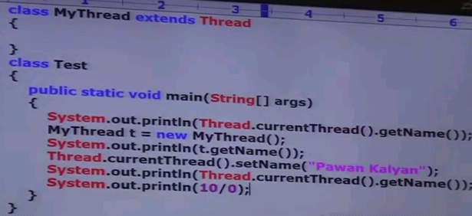

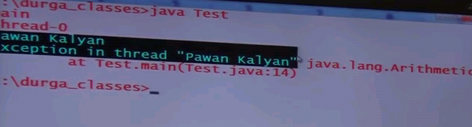

Example to find the implicit main and child thread names.
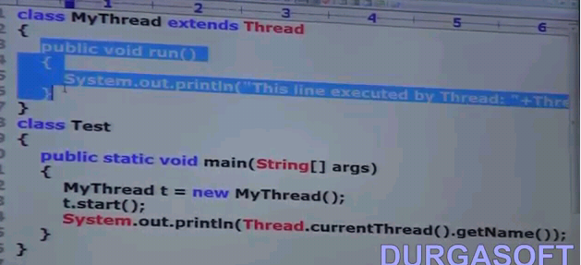


- Thread Priority

Every thread in java has some priority which may be default priority generated by JVM or customized priority provided by developer.

Valid Range of thread priorities is : 1 to 10
Where 1 is min priority, 10 is max priority

Thread class defines the following constants to represent some standard priority.
Thread.MIN_PRIORITY -> 1
Thread.MAX_PRIORITY -> 10
Thread.NORM_PRIORITY -> 5

If two threads having same priority then we cannot expect exact execution order. It depends on thread scheduler.
Get and Set Priority of a Thread:
Thread class defines following methods.
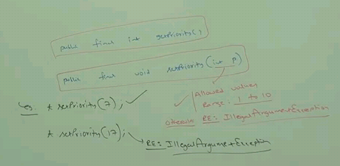

Default Priority:
- The default priority for main thread is 5.
- Remaining threads, default priority will be inherited from parent to child. Here parent refers which thread is executing the child, that thread is called as parent.
Example:
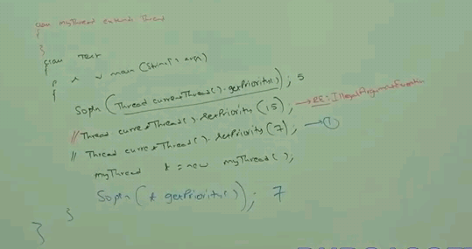
Example:
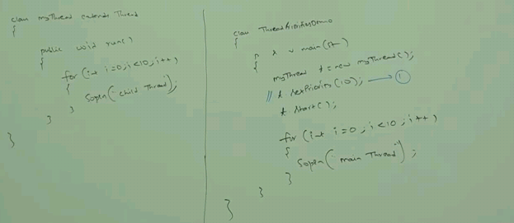
Some OS wont support for Thread priority. If underlying platform wont support thread priority, then we have to get the patch from Microsoft to provide the support for Thread priority.

